**Report: Analyze customer shopping behavior**

1. **Theme:**

* Analyze customer shopping behavior
* Dataset: [**Retail Sales Dataset**](https://www.kaggle.com/datasets/mohammadtalib786/retail-sales-dataset)

1. **Goal:**

Analyze and discover customer shopping trends and behaviors

1. **Question:**

* How does a customer's age and gender affect their purchasing behavior?
* Which product category has the highest appeal to customers?
* What is the relationship between age, spending, and product preferences?
* How do customers adjust their shopping habits to seasonal trends?
* Are there any distinct purchasing behaviors based on the number of items purchased in each transaction?
* What insights can be gleaned from product price allocation in each category?

1. **"Customer Shopping Behavior Analysis" Report**

**Overview Analysis**

* + The total number of transactions in the dataset is 1,000, with an average of 83 transactions per month.
  + Total revenue is $456,000, average monthly revenue is $456
  + The data also shows that women are the customers who make the most transactions, customers aged 36-60 are the main customers, contributing the most to revenue.
  + Although the electronics sector is not the field with the most transactions, it has the highest revenue.
  + Fashion (Clothing) is the most interested field because this is the field with the most transactions.

**Detailed Analysis**

* **Customer Analytics:**

* + **Number of transactions by gender:** 
    - **Women** dominated with **510** transactions (51%), slightly more than  **men 's** 490 transactions.
    - The difference is not too big, but it reflects the shopping habits and preferences commonly seen in women.
  + **Sales by Gender Sectors:** 
    - **Woman:** 
      * Leading in sales in the Beauty and **Clothing sectors,** with a clear superiority over men.
      * This reflects the trend of prioritizing shopping and beauty of this group of customers.
    - **Man:**
      * The Electronics **sector**  is a strength, with revenue of **$80,000**, slightly higher than  **$77,000** from women.
      * This result is in line with men's special interest in technological and technical products
  + **Monthly Revenue:** 
    - **Man:**
      * Sales from men tended **to increase** in February and **May**, but **fell sharply** in **September**. This may be due to the fact that electronic products are usually launched at the beginning of the year
    - **Woman:**
      * Sales tend to increase in **May**, boom in **October** and **December**, but decline in **March** and **November**
    - **Strategy:**
      * Focus on promotions and give incentives, issue discount programs in off-peak months such as 9, 3, and 11 to stimulate shopping demand from customers.
      * Increased promotions and special promotions for electronic products in February and May, as well as fashion and beauty at the end of the year.
* **Product Field Analysis:**

* + **Seasonal revenue analysis of each product area:**
    - **Electronics**:
      * Sales fluctuate seasonally, **peaking in the summer** ($47,000) and **winter** ($48,000).
      * The lowest revenue falls in **the spring**, indicating a decline in demand for e-shopping at this time.
    - **Clothing**:
      * Sales are stable at a decent level, but **spring** is a boom time with **$43,000** .
      * This may be related to the trend of shopping for new clothes because in spring there are often festivals and fashion contests.
    - **Beauty**: although the revenue is lower than the other 2 fields, it still plays a certain role in the total revenue from the store.
    - **Strategy:**
      * **Electronics**: Boost promotions and promotions in the summer and winter to maximize revenue.
      * **Fashion**: Focus on spring fashion campaigns, promote pre-season advertising to take advantage of shopping trends.
      * **Beauty**: Research market demand to improve revenue, combine attractive incentive programs to attract more customers.
  + **Analyze revenue by age group**
    - **Differences in revenue between age groups:**
      * **The 36-60-year-old** and **19-35-year-old** groups account for the majority of revenue, as this is the main workforce with high spending power.
      * **The 61+ age group** and **under 18 years old**  contribute significantly less revenue, in line with the financial ability and consumer needs of these groups.
    - **Level of interest by field in each age group:**
      * **36-60 years old and 61+ years old:**
        + The most interest is in the field of Electronics (Electronics), showing the priority given to technology and utility products.
      * **19-35 years old group:**
        + Especially love the field of Fashion (Clothing), in line with fashion trends and active lifestyles.
      * **Group 0-18 years old:**
        + Mainly interested in the field of Beauty (Beauty), possibly due to the influence of social networks and beauty trends among young people.
    - **Strategy**
      * **Electronics:** Aimed at the 36-60 and 61+ age groups with high-end technology products or home utility devices.
      * **Fashion**: Promote campaigns specifically for the 19-35 age group, focusing on trends and personal style.
      * **Beauty**: Increase promotion on social media platforms to attract young customers from 0-18 years old.
  + **Monthly Revenue Analysis by Sectors**
    - **Electronics:**
      * Sales peaked in **May, October, and December**, indicating a sharp increase in demand during these periods, possibly due to product launches or year-end shopping occasions.
      * In contrast, revenue fell sharply in **September and November**, and especially **bottomed out in March**, when there were few stimulus events.
    - **Beauty Sector:**
      * Revenue tended to be similar to that of the electronics sector, declining in **March, September, and November**, but rising again in **July and October**.
      * This may be related to the need for beauty in the middle and end of the year, when social events take place more frequently.
    - **Clothing Field:**
      * Sales rose sharply in **May and November**, suggesting that this is a time when customers prioritize fashion shopping, which could be related to festive seasons or discounts.
      * Sales fell in July **and September**, reflecting low demand during the summer or seasonal months.
    - **Strategy:**
      * **Electronics**: Strengthen promotional campaigns in May, October, and December; focus on promotions in March and September to stimulate demand.
      * **Beauty**: Promote special promotions in July and October to optimize revenue during the growth period.
      * **Fashion:** Focus on major sales events in May and November, and study more measures to boost sales in July and September**.**
* **Age Group Analysis:**

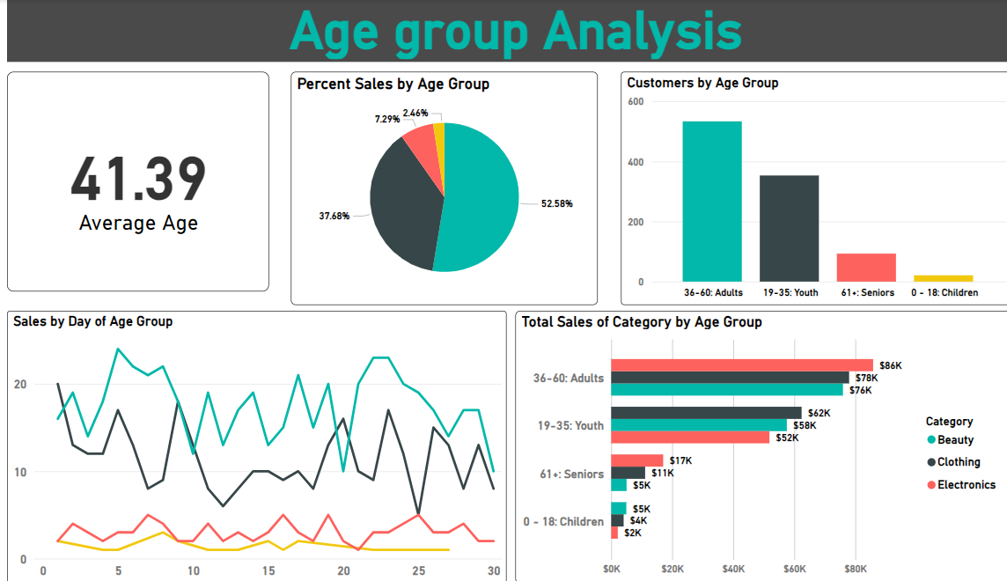

* + The average age of the customers in the dataset was 41.39, in the 36-60 age group. They are suitable for the role of key customers, because these are people who have families, stable careers, and stable finances.
  + **Revenue contribution rate by age group:**
    - **36-60 years old**: The largest contribution with nearly **53%** of total revenue, affirming the position of the main customer group of the store.
    - **19-35 years old**: Ranked second with **37.68%,** showing significant purchasing power from young and dynamic workers.
    - **61+ age group**: Contributing **7.29%,** reflecting the modest spending of the senior age group.
    - **Group 0-18 years old**: Accounting for **2.46%,** in line with the limited spending ability of young customers.
  + **Shopping behavior of the 36-60 year old group:**
    - This group tends to spend more on **the middle of the week**, especially on the **5th, 16th, and 21st-22nd** of the month.
    - It is also the only group to contribute more than **$80,000** to total revenue in  **the Electronics sector**, demonstrating their preference for high-end technology products.
  + **Strategy:**
    - **Focus on marketing strategy**:
      * Aimed at **the 36-60 age** group with midweek promotions and a focus on the Electronics sector.
      * Design campaigns to reach **19-35 year olds** through social media and products that fit modern lifestyles.
    - **Exploit potential customer groups**:
      * For the **61+ age group**, research products or services that are tailored to their needs to increase revenue.
      * Promote the promotion of attractive products for **the 0-18 age group**, take advantage of communication channels suitable for young people.
* **Seasonal Analysis**

* + **Transactions by** 
    - The total number of transactions does not differ too much between seasons
    - Clients tend to trade more in **summer (268 transactions)** and **winter (265 transactions)** than **in spring (236 transactions)** and **autumn (231 transactions).**
  + **Differences in sales by gender across seasons**:
    - **Male customers**: Prefer to shop in **spring** and **summer**, indicating that they prioritize the beginning of the year to spend.
    - **Female customers**: Prioritize purchases in **the fall** and **winter**, possibly due to festive occasions and increased demand at the end of the year.
  + The Electronics sector has outstanding high sales in  **the summer** and **winter**, as well as maintaining higher levels than other sectors in **the fall**. This may reflect a sharp increase in demand for technological equipment procurement during these times.
  + In the spring, the fashion sector has a much higher turnover than the other 2 sectors..... This may be because spring often takes place festivals, fashion contests, etc.
  + **Strategy:**
    - **Boost your campaign:**
      * Focus on summer and winter with Electronics products to take advantage of the increased demand.
      * Launch promotions for female customers at the end of the year to boost sales during the festive seasons.
    - **Reasonable resource allocation:**
      * Ensure sufficient inventory to meet the high demand in summer and winter, especially in the Electronics sector.
      * Encourage spring and fall shopping with attractive offers to reduce revenue disparities between seasons.

1. **CONCLUDE**

* **Key customer groups** 
  + The main customer group of the data set is customers from 36-60 years old, contributing 53% of total revenue, this is the most important customer group.
  + Female customers are the main customers, contributing to 51% of revenue.
* **Electronics**  is the sector that generates the most revenue, contributing **35% of total revenue**, with great interest from male customers and the 36-60 age group
* Shopping behavior:
  + **Summer** and **winter** have the highest number of transactions and revenues, especially in the Electronics sector.
  + **Female customers** prefer to shop at the end of the year (fall and winter), while **male customers** prefer to shop at the beginning of the year (spring and summer).
* **Spend analysis by age group:**
  + The **36-60 age group**  not only  **spends the most**, but also tends to shop in the middle of the week and contributes greatly to Electronics sales**.**
  + The 19-35 **age group**  is more interested in **the fashion** sector, while the **61+** group focuses on **Electronics**, and the **0-18** group focuses on **the beauty sector.**